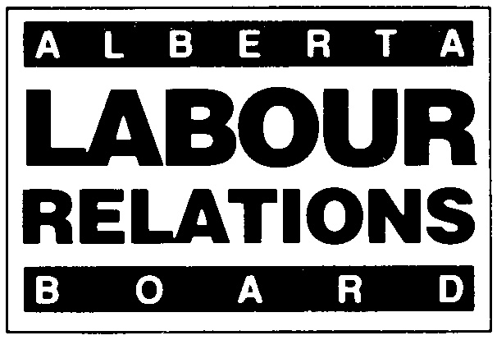 | DECLARATION OF STRIKE VOTE

APPLICABLE PROVISIONS
LABOUR CODE: SECTION 73

VOTING RULE 35

Effective January 1, 2021, the deadline for filing all materials with the Board will change from 4:30 PM to 4:00 PM.
- Form 14 (November 2020)
- Applicants must use this form.
- Rule 35 requires the Returning Officer to complete this declaration as soon as the vote is concluded and file it with the Labour Relations Supervising Officer.
- The results will be made known to the parties as soon as the completed declaration is filed.

TRADE UNION NAME:

EMPLOYER NAME:

RESULTS OF VOTE

Date of Vote:
Total number of employees eligible to vote: ______________
Total number of votes counted (excluding spoiled): ______________
Total number of votes for strike action: ______________
Total number of votes against strike action: ______________
Total number of spoiled ballots: ______________

RETURNING OFFICER’S DECLARATION

FOR BOARD USE ONLY:  Board File Number: ___________________  ___________________________________  Checked by Received by Input by |  | I, _____________________________________, as the Returning Officer responsible for conducting this vote, hereby certify that:  • The results of the vote as reported above are the true and correct results of this vote;  • Only those persons eligible to vote did so;  • There was no interference at or near the polling station with the right of an eligible  voter to vote;  • All ballots were cast in a manner that assured the secrecy of the vote;  • The vote was otherwise also conducted in accordance with Board approved  procedures.  Signed and verified at _______________this ________ day of ___________, 20___.  _____________________________  Signature of Returning Officer

