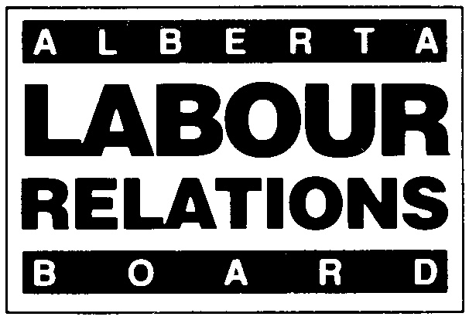 | APPLICATION TO ESTABLISH  AN ARBITRATION BOARD
APPLICABLE SECTION

OF THE ACT: 31(2)

Effective January 1, 2021, the deadline for filing all materials with the Board will change from 4:30 PM to 4:00 PM.
- Form LRB 23 (November 2020). Parties must use this form when seeking to have the Board establish an arbitration board.
- Please type or print clearly. Attach extra pages if necessary.
- The application will be accepted only if completed by the authorized bargaining representative and accompanied by a copy of the current collective agreement.
- For further information refer to Information Bulletin 2 and Rules of Procedure or call the Labour Relations Board at (780) 422-5926 (Edmonton) or (403) 297-4333 (Calgary).
- Any personal information provided herein is collected under the authority of section 33(c) of the Freedom of Information and Protection of Privacy Act (“FOIP”), for the purpose of processing your application to the Labour Relations Board. Any further personal information received in written or oral submissions will be collected under that authority. The collection, use and disclosure of this information is managed pursuant to FOIP. Any information provided to the Board that is relevant to the application must in the normal course be provided to all affected parties to the application, so all parties know the case to be heard and have an opportunity to respond. Questions about the collection or use of personal information can be posed to the Board Officer appointed to your file, or the Board’s FOIP Coordinator at 640, 10155 102 Street, Edmonton, AB, T5J 4G8, or (780) 422-5926.

APPLICANT INFORMATION
Legal Name:  Mailing Address:  Postal Code:  Name of Contact Person:  Address (if different from above):  Postal Code |  | Email Address:  Telephone Number:  Fax Number:  Email Address:  Telephone Number:  Fax Number:
RESPONDENT INFORMATION
Legal Name:  Mailing Address:  Postal Code:  Name of Contact Person:  Address (if different from above):  Postal Code: |  | Email Address:  Telephone Number:  Fax Number:  Email Address:  Telephone Number:  Fax Number:

BARGAINING UNIT INFORMATION
Describe the bargaining unit for which you are seeking an arbitration board:

Certificate Number: (if any and if known)

PARTICULARS
Date of Notice to commence collective bargaining:
Date of first negotiating meeting:
Dates and duration of all subsequent negotiating meetings:
Did you apply to have a mediator appointed? | _______Yes _______ No
If yes, date mediator appointed:
If no, give reasons:

ITEMS IN DISPUTE
List all items the applicant considers are in dispute. Include the article no. and the title of the items. If this is a joint application, prepare a separate list of the items each party considers are in dispute.

FOR BOARD USE ONLY:  Board File Number:  ________________________________  ________________________________  Checked by Received by Input by |  | Signature of authorized bargaining representative:  ______________________________________________________________  Printed Name: _______________________________________________  Position:_____________________________________________________  Date of Signing: _______________________________________________
Current collective agreement received |  | Complete and deliver to:  Labour Relations Board Labour Relations Board  #640, 10155 – 102 Street #308, 1212 31 Avenue, N.E.  Edmonton, AB T5J 4G8 Calgary, Alberta T2E 7S8  Fax: (780) 422-0970  (Applications can be emailed to the Board at ALRB.EDM@gov.ab.ca  The Board does not require original applications.)

