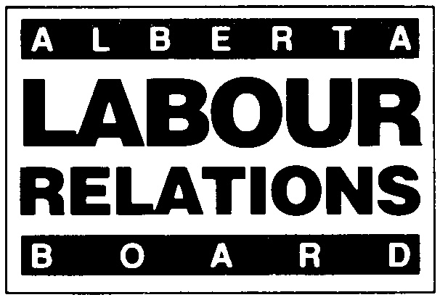 | EMPLOYEE APPLICATION FOR  REVOCATION OF BARGAINING RIGHTS
APPLICABLE SECTIONS:
51 OF THE CODE; 18 OF THE ACT

Effective January 1, 2021, the deadline for filing all materials with the Board will change from 4:30 PM to 4:00 PM.
- Form LRB 05 (November 2020). Please type or print clearly.
- Employees may use this form to assist in making a complete application.
- For information or assistance in completing this form, refer to Information Bulletin 13 and the Rules of Procedure or call the Labour
Relations Board at (780) 422-5926 (Edmonton) or (403) 297-4334 (Calgary).
- Employees wishing to have the bargaining rights of their union revoked should select a person to act as their contact person with the Board. Only the contact person’s name will be released to the employer and the union.
- Any personal information provided herein is collected under the authority of section 33(c) of the Freedom of Information and Protection of Privacy Act (“FOIP”), for the purpose of processing your application to the Labour Relations Board. Any further personal information received in written or oral submissions will be collected under that authority. The collection, use and disclosure of this information is managed pursuant to FOIP. Any information provided to the Board that is relevant to the application must in the normal course be provided to all affected parties to the application, so all parties know the case to be heard and have an opportunity to respond. Under section 14(6) of the Labour Relations Code, the Board is not required to divulge any information about a person’s union membership status or support. Questions about the collection or use of personal information can be posed to the Board Officer appointed to your file, or the Board’s FOIP Coordinator at 640, 10155 102 Street, Edmonton, AB, T5J 4G8, or (780) 422-5926.

APPLICANT INFORMATION
• contact person for the employees signing the petition  Name:  Complete Mailing address:  Postal Code: | Business Telephone:  Residence Telephone: | Fax Number:  Email Address:
Name of Spokesperson (If different from above):  Address (I):  Postal Code: | Telephone Number:  Fax Number: | Email Address:

TRADE UNION INFORMATION
Legal Name:  Mailing Address:  Postal Code:  Name of Contact Person:  Address (if different from above):  Postal Code: |  | Local Number:  Email Address:  Email Address:  Telephone Number:  Fax Number:

BARGAINING UNIT INFORMATION
• Describe the bargaining unit for which you are seeking revocation:

Is there a collective agreement in effect? _____ Yes _____ No

What is the term of the collective agreement: _________ to _________
(date) (date)
Certificate Number: (if any and if known)

EMPLOYER INFORMATION
• Who is your employer?  Legal Name:  Mailing Address:  Postal Code:  Name of Contact Person (if known):  Mailing Address: (if different from above).  Postal Code |  | Email Address:  Telephone Number:  Fax Number:  Email Address:  Telephone Number:  Fax Number:

EMPLOYEE SUPPORT
• Attach petition(s) signed by at least 40% of the employees in the bargaining unit represented by the trade union.

_____ Number of petition forms
_____ Number of signatures on petition
_____ Number of employees in the bargaining unit

DECLARATION OF THE CONTACT PERSON OR SPOKESPERSON
• The contact person or spokesperson must sign this declaration to show that the signatures of the employees were obtained freely
according to the Labour Relations Code.

• The contact person or spokesperson must be prepared to attend any hearing and verify the authenticity of the petition.

I declare that to the best of my knowledge, the signatures of the employees on the attached petitions were obtained freely and that the information in this application is true and correct.

Signature of Applicant: _____________________________________________________________________________________
Printed Name: ____________________________________________________________________________________________
Date: ___________________________________________________________________________________________________

FOR BOARD USE ONLY:  Board File Number: _________________  _________________________________  Checked by Received by Input by  Petition(s) Received _______ |  | Signature of Applicant: ____________________________________________  Printed Name: __________________________________________________  Date of Signing: __________________________________________________
Complete and deliver to:

Labour Relations Board Labour Relations Board
#640, 10155 – 102 Street #308, 1212 31 Avenue, N.E.
Edmonton, Alberta Calgary, Alberta
T5J 4G8 T2E 7S8
Fax: (780) 422 - 0970

(Applications can be emailed to the Board at ALRB.EDM@gov.ab.ca
The Board does not require original applications.)

