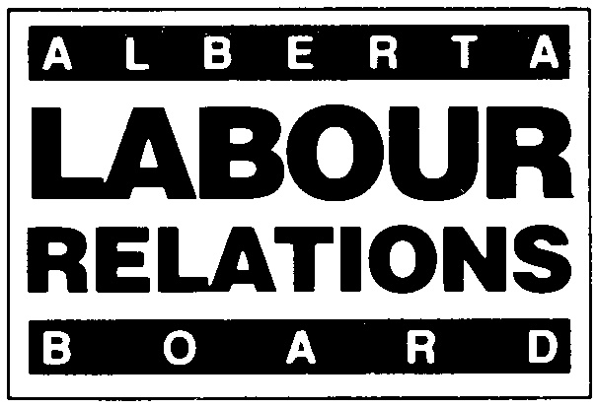 | TRADE UNION FILING
APPLICABLE SECTIONS:
24 OF THE CODE; 4 OF THE ACT

Effective January 1, 2021, the deadline for filing all materials with the Board will change from 4:30 PM to 4:00 PM.
- Form LRB 07-A. (November 2020). Please type or print clearly.
- For Trade Union Name Change or Trade Union Successorship use Application for Trade Union Name Change or Successorship Form (LRB 07-B).
- Refer to Information Bulletin 7 and the Rules of Procedure or call the Labour Relations Board at (780) 422-5926 (Edmonton) or
(403) 297-4334 (Calgary).
- Any personal information provided herein is collected under the authority of section 33(c) of the Freedom of Information and Protection of Privacy Act (“FOIP”), for the purpose of processing this filing with the Labour Relations Board. The collection, use and disclosure of this information is managed pursuant to FOIP. Questions about the Board’s collection or use of personal information can be posed to the Board’s FOIP Coordinator at 640, 10155 102 Street, Edmonton, AB, T5J 4G8, or (780) 422-5926.

Date of Filing:

Is this filing (please check one) _____ a new filing ____ changes to information previously filed (except a name change).

LOCAL TRADE UNION INFORMATION

Legal Name:  Mailing Address:  Postal Code:  Email Address: |  | Local Number:  Telephone Number:  Fax Number:

PARENT TRADE UNION INFORMATION (if different from above)

Legal Name:  Mailing Address:  Postal Code:  Email Address: |  | Local Number:  Telephone Number:  Fax Number:

ATTACHED DOCUMENTS: (please check)

• Please attach TWO copies of your Constitutional Documents.
____ Constitution (dated))
____ Charter (dated)
____ By-laws (dated)
____ Incorporating Documents (dated)
____ Other (please specify)

OFFICERS AND ORGANIZERS OF THE TRADE UNION:

(List Local Union Officers for a Local Union Filing.)

NAME TITLE MAILING ADDRESS PHONE FAX EMAIL

PERSONS AUTHORIZED TO SIGN COLLECTIVE AGREEMENTS IN ALBERTA

 | NAME TITLE MAILING ADDRESS PHONE FAX EMAIL
FOR BOARD USE ONLY:  Board File Number: ____________________  _____________________________________  Checked by Received by Input by |  |  | Signature: ______________________________________________________  Print Name: _____________________________________________________  Position: ________________________________________________________  Date of Signing: __________________________________________________
Complete and deliver to:

Labour Relations Board Labour Relations Board
#640, 10155 – 102 Street #308, 1212 31 Avenue, N.E.
Edmonton, AB T5J 4G8 Calgary, AB T2E 7S8
Fax: (780) 422-0970

(Applications can be emailed to the Board at ALRB.EDM@gov.ab.ca
Two copies of other documents must be mailed or hand delivered.)

