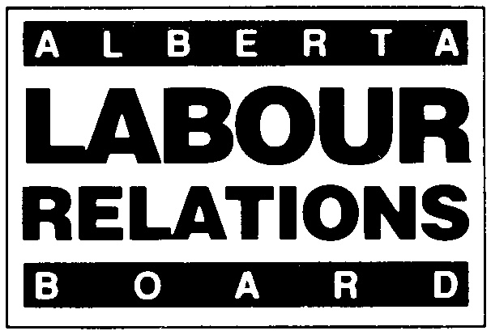 | APPLICATION FOR TRADE UNION NAME  CHANGE OR SUCCESSORSHIP
APPLICABLE SECTIONS;
12(4) AND 49 OF THE CODE;
66 OF THE ACT

Effective January 1, 2021, the deadline for filing all materials with the Board will change from 4:30 PM to 4:00 PM.
- Form LRB 07-B (November 2020). Please type or print clearly. Attach extra pages if necessary.
- Refer to Information Bulletin #7 and the Rules of Procedure or call the Labour Relations Board at (780) 422-5926 (Edmonton) or
(403) 297-4334 (Calgary).
- Any personal information provided herein is collected under the authority of section 33(c) of the Freedom of Information and Protection of Privacy Act (“FOIP”), for the purpose of processing this filing with the Labour Relations Board. The collection, use and disclosure of this information is managed pursuant to FOIP. Questions about the Board’s collection or use of personal information can be posed to the Board’s FOIP Coordinator at 640, 10155 102 Street, Edmonton, AB, T5J 4G8, or (780) 422-5926.

Is this: (check as appropriate)
- _____ Just a change in the trade union’s name. Date of change: ____________________________________.
- _____ A transfer of a trade union’s jurisdiction (Complete the attached Trade Union Successorship Declaration).
- _____ A merger or amalgamation of trade unions. (Complete the attached Trade Union Successorship Declaration).
- If 2 or 3, does the change also involve a change to the trade union name? ____ Yes ____ No

APPLICATION INFORMATION
Legal Name:  Former Name:  Name of Contact Person(s):  Mailing Address:  Postal Code: |  | Local Number:  Local Number:  Telephone Number:  Fax Number:  Email Address:

AFFECTED BARGAINING RELATIONSHIPS

(List employer names, contact information, and certificate numbers if known. Attach extra pages if necessary.)

FOR BOARD USE ONLY:  Board File Number: ____________________  _____________________________________  Checked by Received by Input by |  | Signature: ______________________________________________________  Print Name: _____________________________________________________  Position: ________________________________________________________  Date of Signing: __________________________________________________
Complete and deliver to:

Labour Relations Board Labour Relations Board
#640, 10155 – 102 Street #308, 1212 31 Avenue, N.E.
Edmonton, Alberta Calgary, Alberta
T5J 4G8 T2E 7S8
Fax: (780) 422 – 0970

(Applications can be emailed to the Board at ALRB.EDM@gov.ab.ca
Two copies of other documents must be mailed or hand-delivered.)

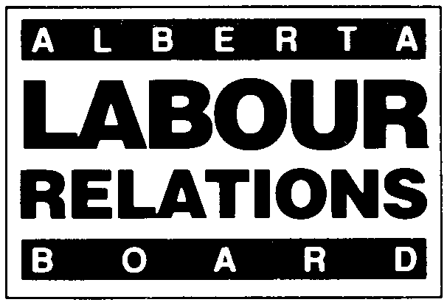 | TRADE UNION  SUCCESSORSHIP DECLARATION

Two (2) of the most current copies of following documents must be filed with the Board:
______ Constitution – Date of the latest version: ___________________________________________________________________
______ Charter – Date of Charter: _____________________________________________________________________________
______ By-laws – Date of the latest version: ______________________________________________________________________
______ Incorporating Documents (required if this is a new trade union)
______ List of Local Union Officers - Date of the latest version: ________________________________________________________

Is this a merger _________ or transfer of jurisdiction _________? (check one)
Do the constitution/bylaws of the surrendering/receiving unions permit the reorganization? | _____Yes ______No
Which Articles of the constitution/bylaws apply?

Is there consent of the membership(s) of the surrendering and receiving unions to the reorganization? | _____Yes ______No
Was appropriate notice given to members of the surrendering and receiving unions of the merger meeting? | _____Yes ______No
If yes, provide the manner in which the consent was requested and given.
(Example – motion passed at a meeting as defined by the constitutional merger procedure)

If required, has a valid constitutional amendment been passed to permit the merger? | _____Yes ______No
Did any bar exist to the passage of the merger motion?  If yes, explain: | _____Yes ______No
Is the transaction complete? If yes, provide date of completion: | _____Yes ______No
Has a new charter been issued? | _____Yes ______No
Has an existing charter been revised? | _____Yes ______No
Has an existing charter been revoked? | _____Yes ______No

I declare that, to the best of my knowledge, the information contained in this declaration is accurate. I further confirm that the requirements of the unions’ Constitution and/or By-laws have been met.
Signature: _______________________________________ | Date of Signing: _____________________________
Applicant’s Representative
Printed Name: ____________________________________ | Position: ____________________________________

